**United States Department of Agriculture**

Food and Nutrition Service



**FNS Office of Information Technology**

**Portfolio Management Division (PMD)**

**FNS System Design Document Template**

**for**

**[Project or System Name]**

**Version 1.1**

September 09, 2013

**Revision History**

|  |  |  |  |
| --- | --- | --- | --- |
| **Version** | **Date** | **Author** | **Change Description** |
| 1.0 | 03-21-2013 | IT Governance Branch (ITGB) | Created the document |
| 1.1 | 09-09-2013 | IT Governance Branch (ITGB) | Re-formatted the document. |
| 1.2 |  |  |  |
| 1.3 |  |  |  |

**Contact Information**

|  |  |
| --- | --- |
| **Area of Concern** | **Contact Person** |
| IT Governance Lead | Kevin Russ |
| SDLC Coordinator | Syed Jaffery |
| ITIRB Coordinator | Sunny Dilawari |
| Portfolio Management Division Director, Chief Portfolio Officer | Jacqueline Butler |
| Program Management Branch Chief | Allison Willcox |

Contents

Glossary 4

1. Introduction 5

1.1. Purpose of System Design Document 5

1.2. Scope 5

1.3. System Overview 5

2. Points of Contact 5

3. System Architecture 6

3.1. System Hardware Architecture 6

3.2. System Software Architecture 6

3.3. File and Database Architecture 6

4. Detailed Design 8

4.1. User Interface 8

4.2. Application Security 9

4.3. Module Detail Design 9

Appendix A: References 12

Approvals/Signatures 13

# Glossary

| **Acronym** | **Description** |
| --- | --- |
|  |  |
|  |  |
|  |  |
|  |  |
|  |  |
|  |  |
|  |  |
|  |  |

# Introduction

## Purpose of System Design Document

Describe the purpose of System Design Document.

## Scope

Provide a description of the intended scope of the system, how it will accomplish its purpose.

## System Overview

Provide a brief system description and the high level functionality provided by the system.

**System Description**

Describe the system in narrative form using non-technical terms.

**Design Constraints**

Describe any constraints in the system design (reference any trade-off analyses conducted such as resource use versus productivity, or conflicts with other systems) and include any assumptions made by the project team in developing the system design.

**Future Contingencies**

| **No.** | **Design Contingencies** | **Workarounds/Alternative Plans** |
| --- | --- | --- |
| 1 | Describe any contingencies that might arise in the design of the system that may change the development direction. For example:   1. Lack of interface agreements with outside agencies, 2. Unstable architectures at the time this document is produced. | Address any possible workarounds or alternative plans. |
|  |  |  |
|  |  |  |

# Points of Contact

List the names, titles, and contact information of the major participants in the project.

| **Name** | **Title** | **Contact Phone Number** | **Contact Email** |
| --- | --- | --- | --- |
|  | Project Sponsor |  |  |
|  | OIT Project Manager |  |  |
|  | SME |  |  |
|  | Business Analyst |  |  |
|  | Architect |  |  |
|  | Developer |  |  |
|  | Tester |  |  |
|  | End User |  |  |

# System Architecture

Describe the system and/or subsystem(s) architecture for the project.

## System Hardware Architecture

In this section, describe the overall system hardware and organization. Include a list of hardware components (with a brief description of each item) and diagrams showing the connectivity between the components.

| **No.** | **Hardware** | | **Description** |
| --- | --- | --- | --- |
| 1 | Name of the hardware. | Description of hardware. | |
| 2 |  |  | |
| 3 |  |  | |

## System Software Architecture

In this section, describe the overall system software and organization. Include a list of software modules.

## File and Database Architecture

The section should describe the final design of all Database Management System (DBMS) files and the non-DBMS files associated with the system under development.

**Database Management System Architecture**

Describe the final design of all Database Management System (DBMS) files.

**Tables**

Provide normalized table layout. For example:

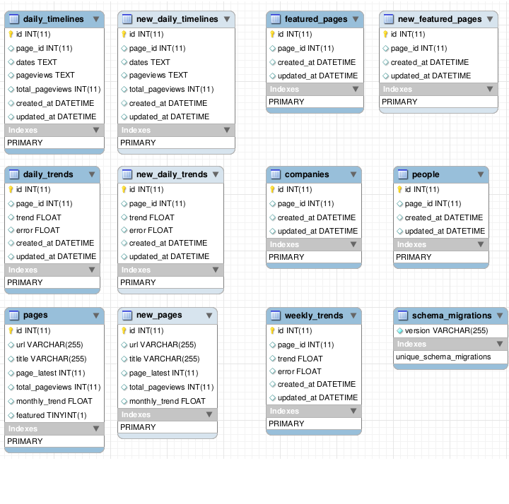

**Entity Relationship Diagrams**

Provide Entity Relationship Diagrams, and other logical design information. For example:

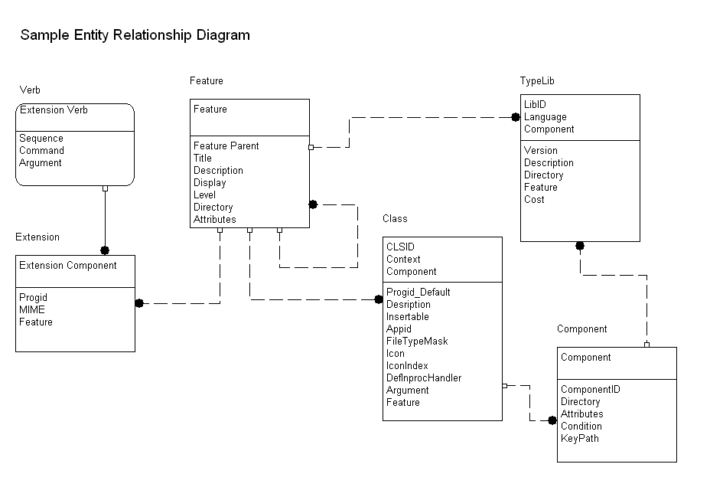

**DBMS Schemas**

Provide physical description of the DBMS schemas, sub-schemas, records, sets, tables, storage page sizes, etc.

**Impacts**

Describe the impact/s (if applicable) of the data requirements on equipment, software, user and developer organizations. An estimate of the data storage requirements in terms of size and number of records should be provided.

# Detailed Design

## User Interface

**Screens and Data Fields**

Provide a graphic representation of each layout and define all data elements associated with the layout or reference the data dictionary.

**Reports**

Provide graphical representation of reports (if any) that are part of the system.

For example:

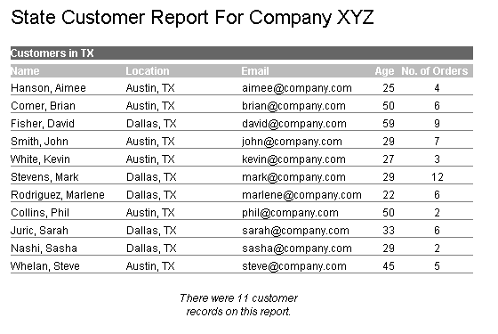

## Application Security

Describe the application/system's user authentication control mechanisms (password, token, and biometrics). Discuss the controls in place to authorize or restrict the activities of users and personnel within the application/system. If the general public accesses the application/system, discuss the additional security controls used to protect the application/system's integrity.

Provide the information needed for a system development team to actually build and integrate the hardware components, code and integrate the software modules, and interconnect the hardware and software segments into a functional product.

## Module Detail Design

**Description of Module**

Provide a detailed description of each software module.

**Module Constraints**

Identify any relevant assumptions, limitations, or constraints for this component. This should include constraints on timing, storage, or component state, and might include rules for interacting with this component.

**Function(s)/Services**

List functions and services related to this module.

**Data Model**

Provide specific data model diagram for the module.

For example:

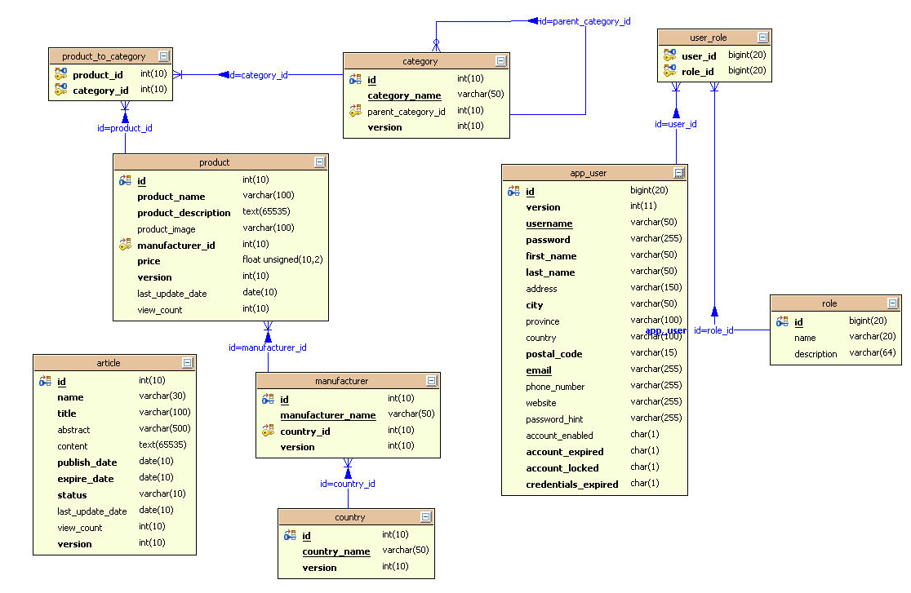

**Graphical Representation**

Provide graphical representation of the module. For example:

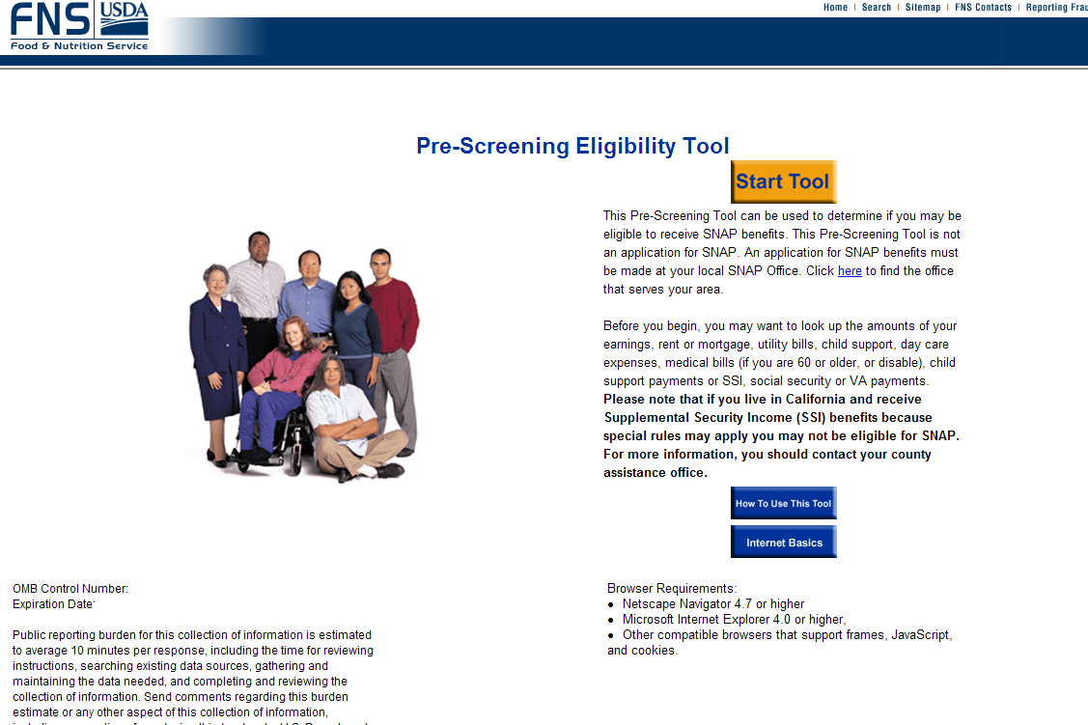

# Appendix A: References

Insert the name, version number, description, and physical location of any documents referenced in this document. Add rows to the table as necessary.

The following table summarizes the documents referenced in this document.

|  |  |  |
| --- | --- | --- |
| **Document Name** | **Description** | **Location** |
| Document Name and Version Number | Document description | URL or Network path where document is located |
|  |  |  |
|  |  |  |

# Approvals/Signatures

The undersigned acknowledge that they have reviewed the [name of document] document and agree with the information presented within this document. Changes to this document will be coordinated with, and approved by, the undersigned, or their designated representatives.

|  |  |  |  |
| --- | --- | --- | --- |
| Signature: |  | Date: |  |
| Print Name: |  |  |  |
| Title: |  |  |  |
| Role: | [Project or System Name] Project Manager |  |  |
|  |  |  |  |
| Signature: |  | Date: |  |
| Print Name: |  |  |  |
| Title: |  |  |  |
| Role: | [Project or System Name] Business Owner |  |  |
|  |  |  |  |
| Signature: |  | Date: |  |
| Print Name: |  |  |  |
| Title: |  |  |  |
| Role: | Organization’s Approving Authority |  |  |